Requirements Analysis Document
SC394-702 Muscarello 10/2/20

- Introduction

  - Purpose of the system

This project will be used as a work collaboration site for anyone. We are developing a web-based implementation that will allow faculty, students, and administrator. Student users are assigned to project teams by the Faculty member. Students can communicate with other team members and Faculty. Students can use any features to set goals and measure their effective delivery. Faculty can attach grades as well as view all schedules, and comments. The website based on how many awards you have, will give awards to users. Administrators can create projects, delete projects, create accounts, delete data and accounts – all the usual superuser privileges.

Scope of the system

This project will consist of a web-based implementation of a more dynamic system where faculty, students and administrators will have a more interactive relationship. This project will be completed by November 2020. This project will be focused on an environment that allows students and faculty to better organize their projects.

Objectives and success criteria of the project

    - Create a webpage that allows a user to actively track and review projects they are working on or have already completed.

    - Implement a chat feature that allows users to communicate real time with their group/peers.

    - Store all messages, tasks, projects, and reviews in a database.

Definitions, acronyms, and abbreviations

    - AdobeXD - Prototyping tool for user experience and interaction designers.
      - vector-based user experience design tool for web apps and mobile apps, developed and published by Adobe Inc.
    - SQLDBM- Structured Query Language
      - used to Create tables and define relationships between them.
    - RAD - Requirements Analysis Document
      - specifically details what is needed for the successful development of the product

References

http://www.cs.fsu.edu/~lacher/courses/COP3331/rad.html Source of Requirements Analysis Document

http://www.doit.state.nm.us/project_templates.html
Project Management Tools

https://github.com/
Development platform

Overview

Due to the pandemic and growing number of problems by people working from home, we are building a more dynamic system where faculty, students and administrators will have a more interactive relationship. It is the goal of our team to build a system where faculty will be able to assign students users to project teams, communicate, view all schedules, comments, awards, create projects, can edit and delete their profiles, can attach and appoint grades and finally make comments and give awards. To bring users a fun and interesting way to use the system, our team will build a “emoji like” application that allows users to change their avatars and give awards. We hope to have a program that is completely web-based.

- Current system

Currently there are programs that allow users to either create and track a project with a team or websites such as D2L which allow faculty to simply post the project and the students must find a way to track their project. This system lacks the ability to allow faculty to actively track their students’ progress without the need for the student to submit an assignment. Students also have the ability to easily communicate with their groups without having to go outside the project tracking environment.

- Proposed system

In order to create an environment that allows students and faculty to better organize their projects, our team proposes making a website that allows faculty to create projects for their students in which the students can then view and submit each task for faculty and peer review. The students also will have the ability to chat with their entire group or individual group members. Statistics will also be provided for each user, so they can see the number of tasks remaining, their average peer review scores, badges given, etc. To motivate good work from team members, we will implement a peer rating system which allows each peer to rate user’s task anonymously and only the user and faculty will be able to see their individual scores. Users will also have the option of awarding badges if they think a task was completed exceptionally well.

Overview

  - Functional requirements
3.2.1 Chat should show messages in real time
3.2.2 Database should collect and store all user/faculty data
3.2.3 Data should be retrievable for analytics
3.2.4 Charts to populate to show project statistics

  - Nonfunctional requirements

    - Usability

For the time being, this application will be used on a windows computer. The interface will favor usability over flexibility with the goal of appealing to users of all skill levels. The system will also be designed for recognition over recall, in which users will be able to figure out how to interact with the system without much instruction. To further the overall usability of the system, coach-marks may be included for first-time users as small instructional aids.

Reliability

For use on a personal machine, desktop or laptop, the system will be fully usable; however, the system will not be specifically tailored for mobile devices. The system will be available for use as long as the server is running. In real-world implementations, the system would be able to be available 24/7 so long as the user has a reliable internet connection.

Performance

Performance mainly depends on a user’s computer and internet speed. The connection to the database server will most likely be the bottleneck when it comes to performance since data such as task messages involve a number or queries to retrieve all of it. Also generating statistics can cause a drop-in performance as the complexity or a project increases since the JavaScript that is creating each graph/chart will be executed on the host machine rather than on the server.

Supportability

The system will support practically every modern web browser with an internet connection. Given the complexity of the system, it will be difficult to port over to mobile versions without sacrificing on functionality or user experience. Some tablets may support the system as many mobile web browsers allow the user of the desktop version.

Implementation

Given the complexity of the system, it will only be implemented on a desktop web browser. The system will be created and tested on desktop computers. Our team plans on testing the system with reallocated data and actively using the program.

Interface

The interface will mainly be data driven. Depending on the tab the user clicks, the main content will change to dynamically show the data. For example, if the user clicks on their profile, it will show their personal information such as their name, title, etc. Also, it will show statistics such as their peer rating and number of badges they were awarded. Like this, for each tab, the layout will alter to show the data in the most efficient way possible.

Packaging: N/A

    - Legal: N/A

  - System models

    - Scenarios

A user tests the implementation by going to the MacroHard website. The user starts at the login screen where they will be asked their credentials to log in. When the user logs in, they will see the main page that shows all the groups they are in. When clicking on a group, the page will populate with all the tasks the group will need to complete. When the user completes a task and it is approved by a faculty member, the other member in the group will have the opportunity to give a rating from 1 - 5, as well as an optional badge. There is also a tab on the right that allows the user to chat with their peers. This can be done with either their entire group or a selection.

Use Case Model

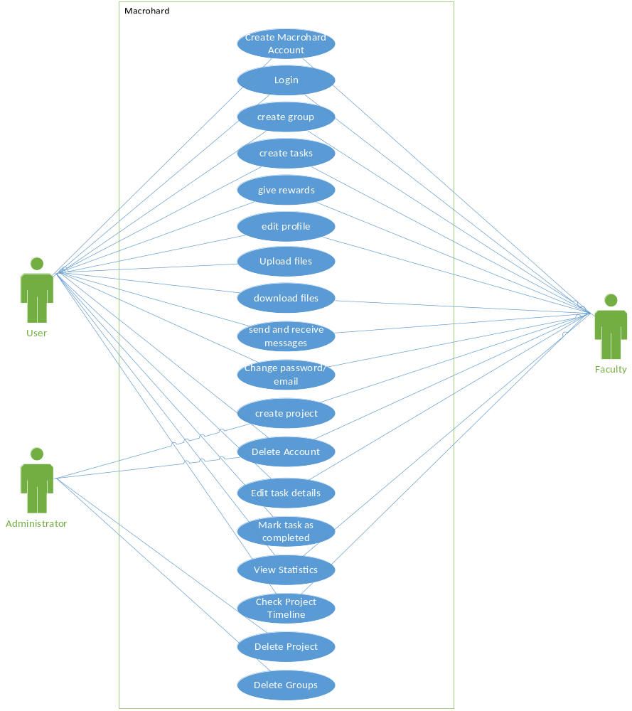

analysis Object Model
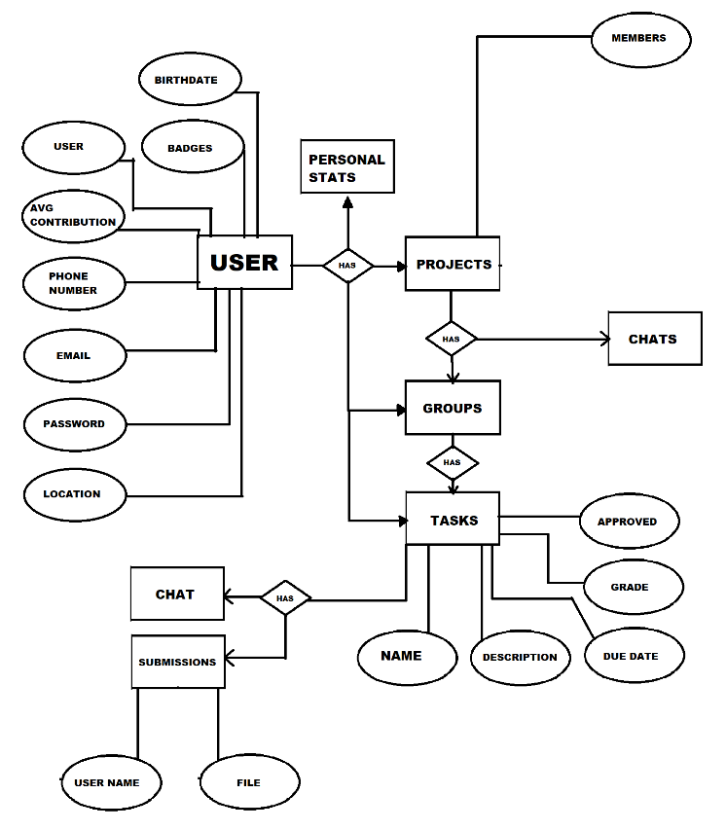

Diagram 2: Displays interaction between users and the web browser.

Dynamic Model
N/A

User interface—navigational paths and screen mock-ups

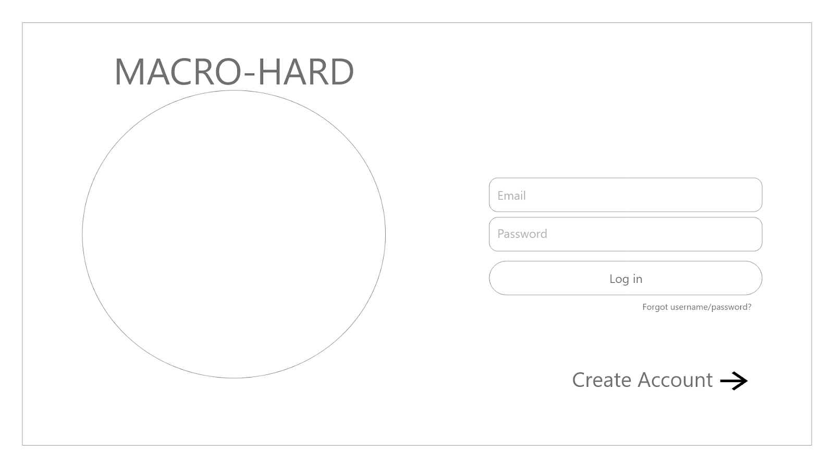
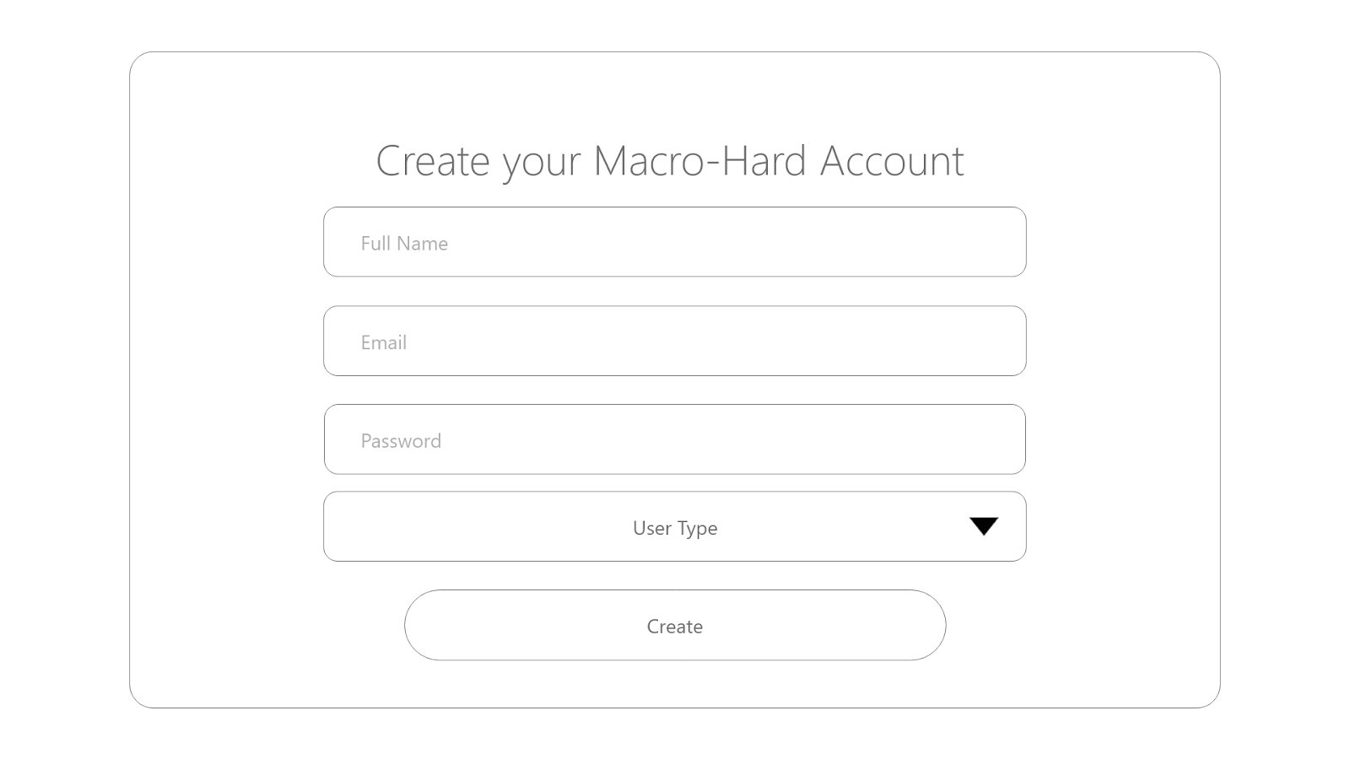
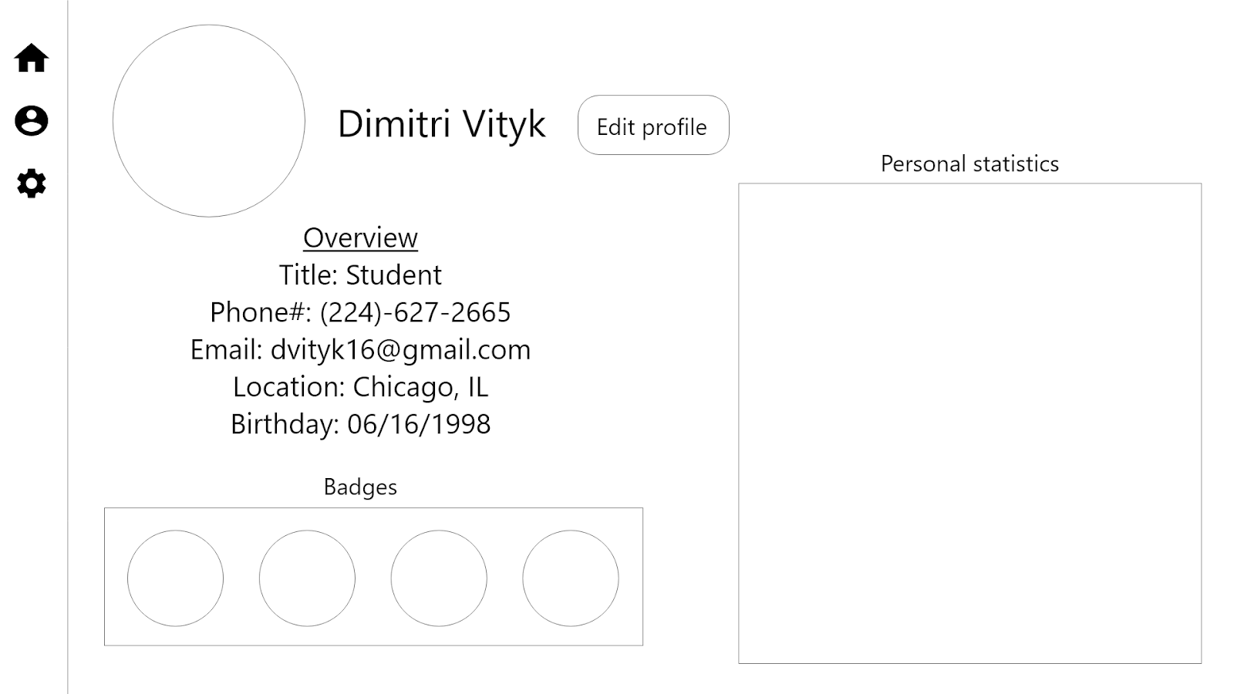
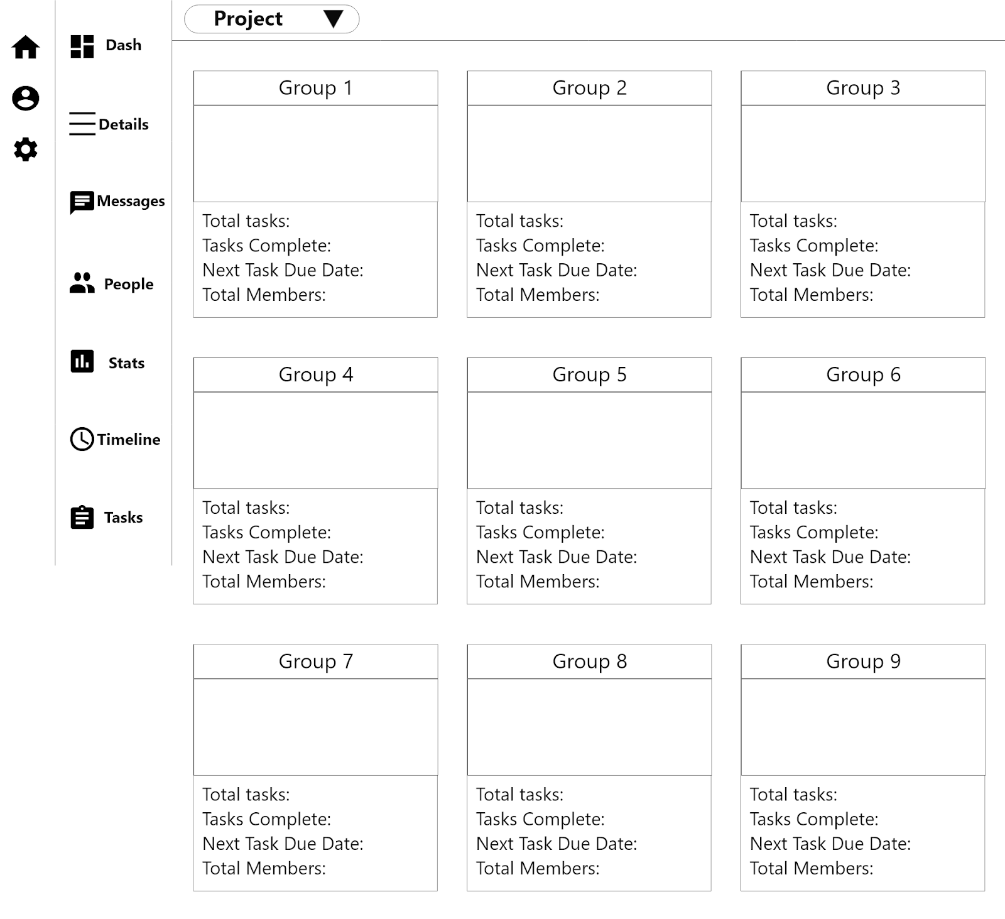
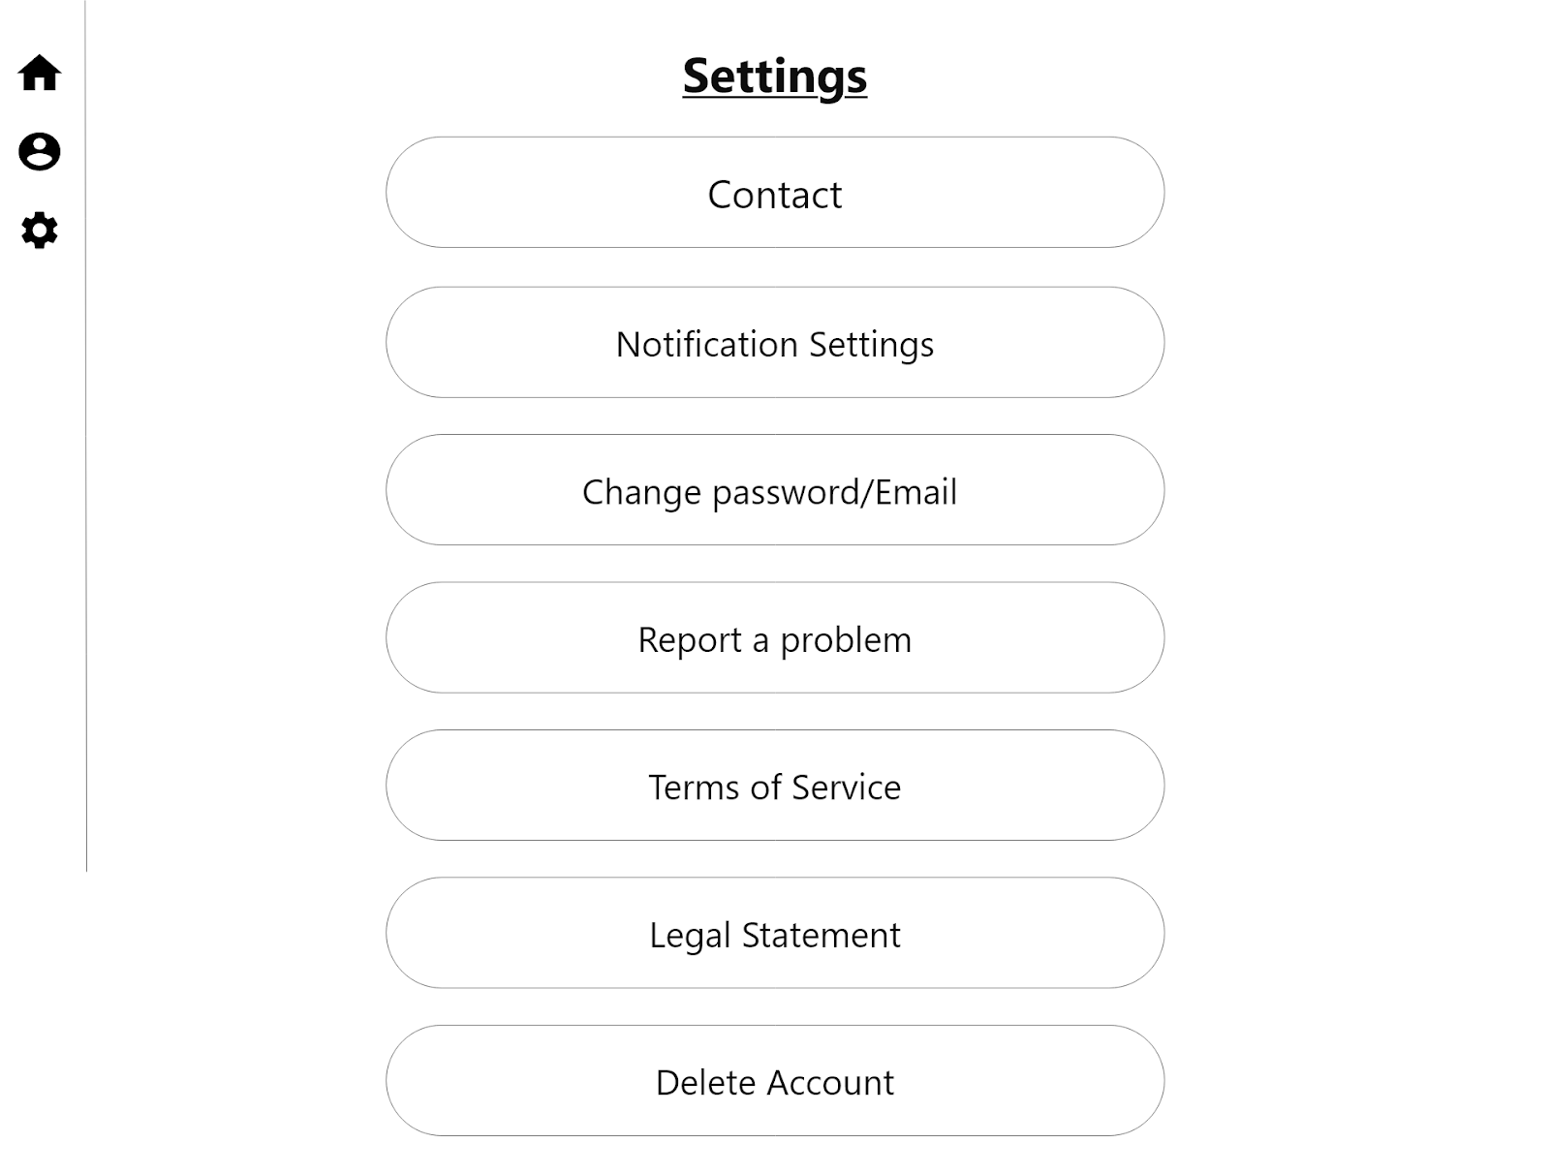
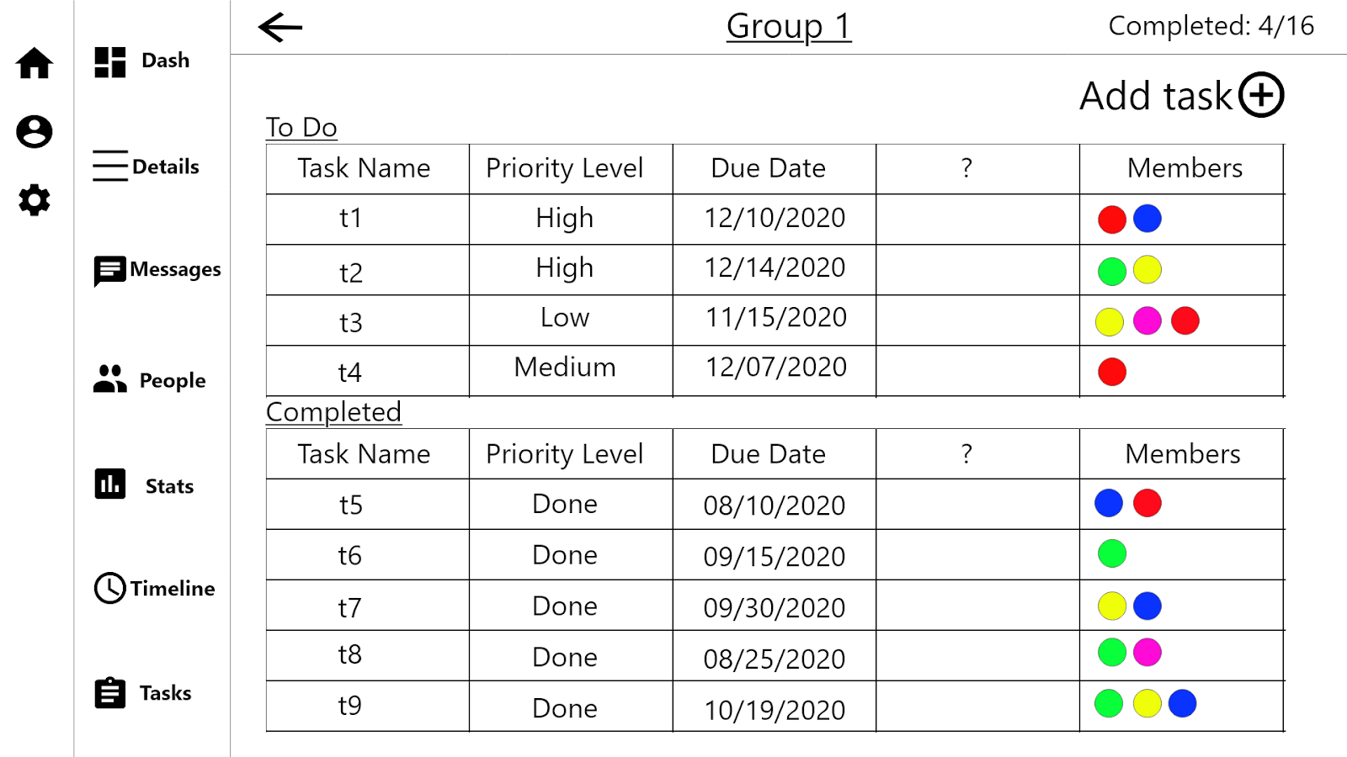
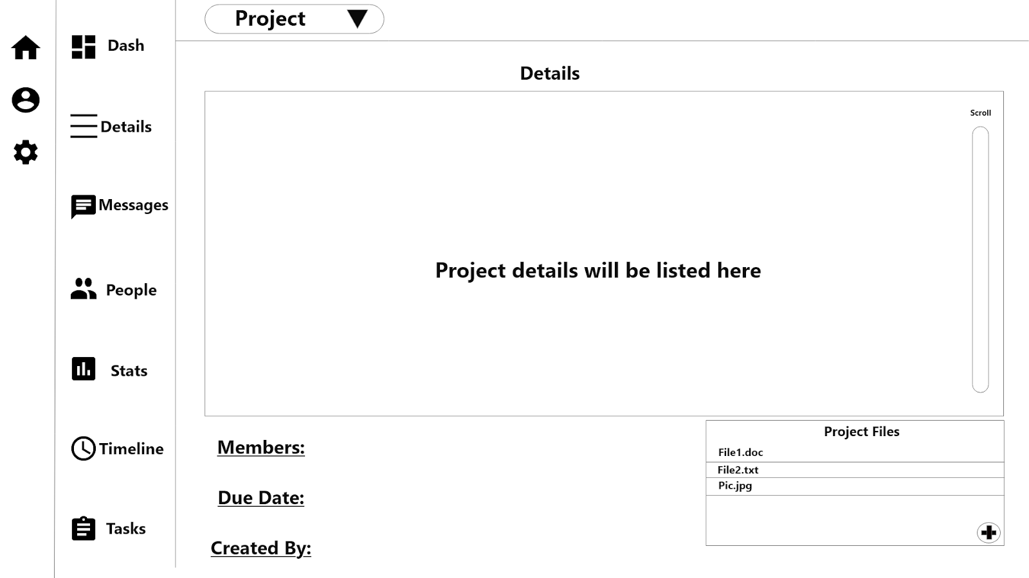
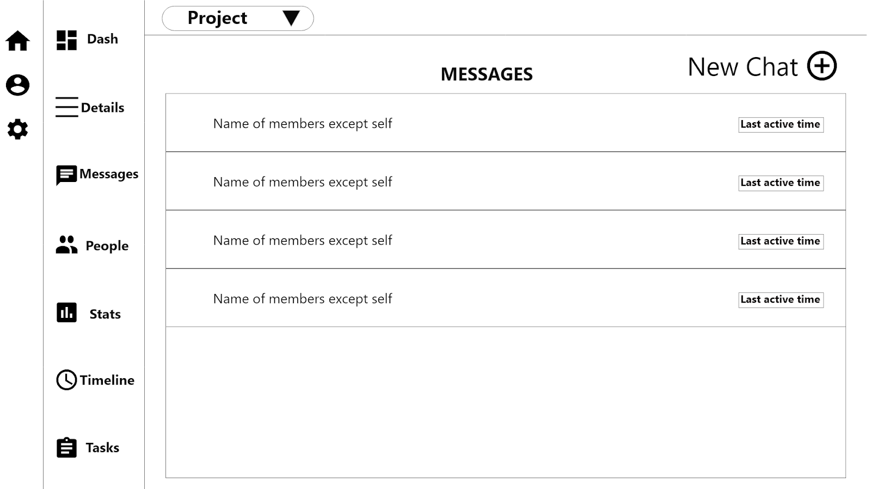
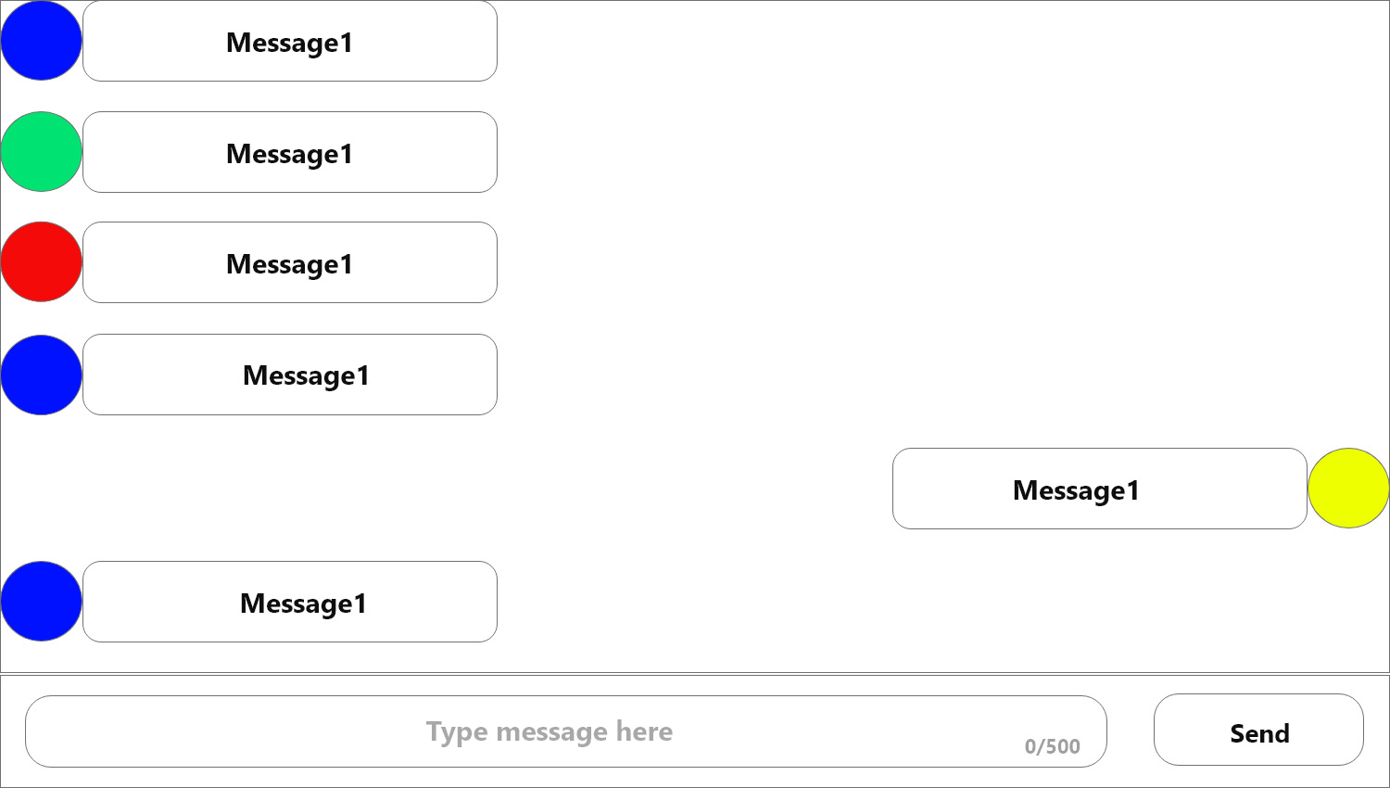
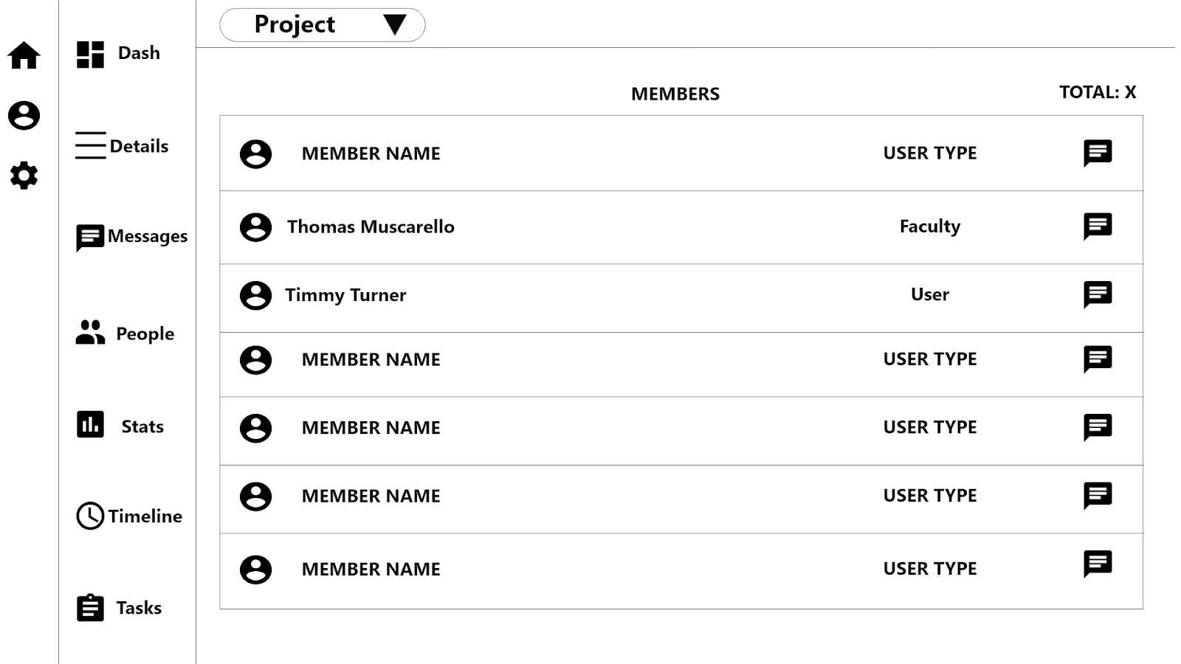
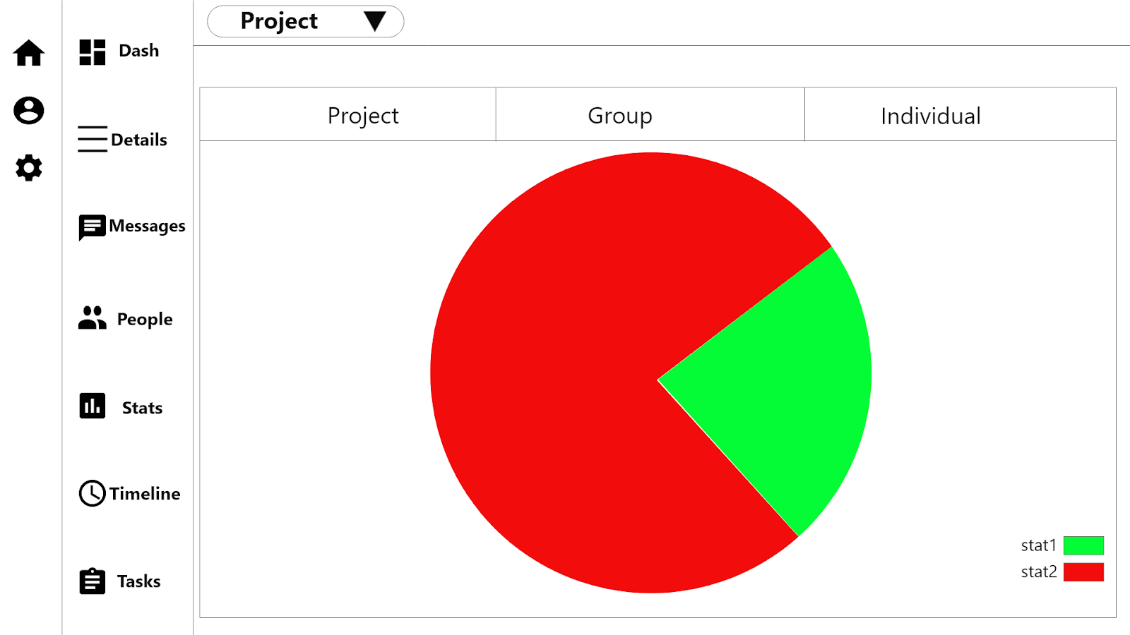
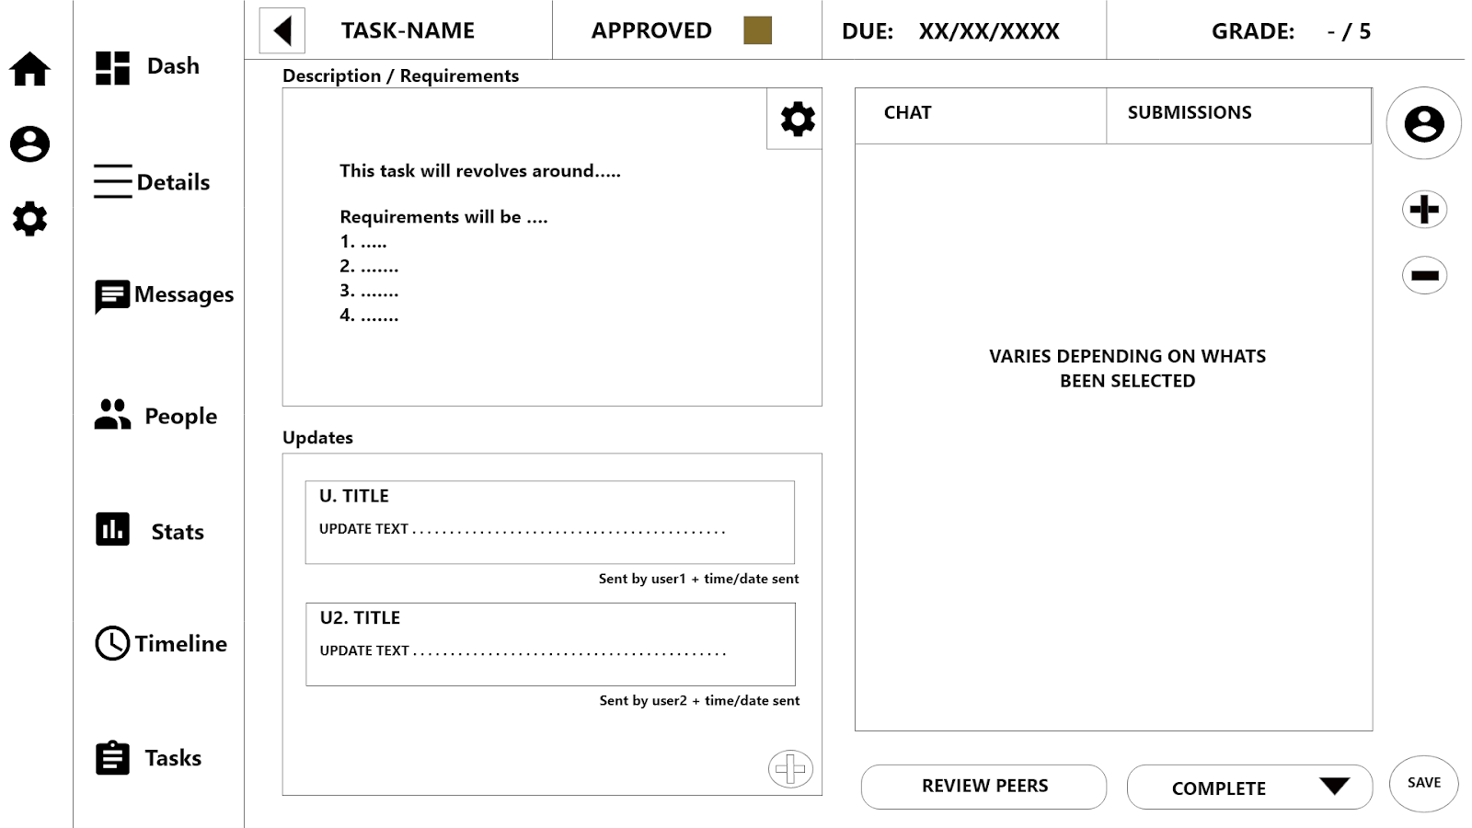
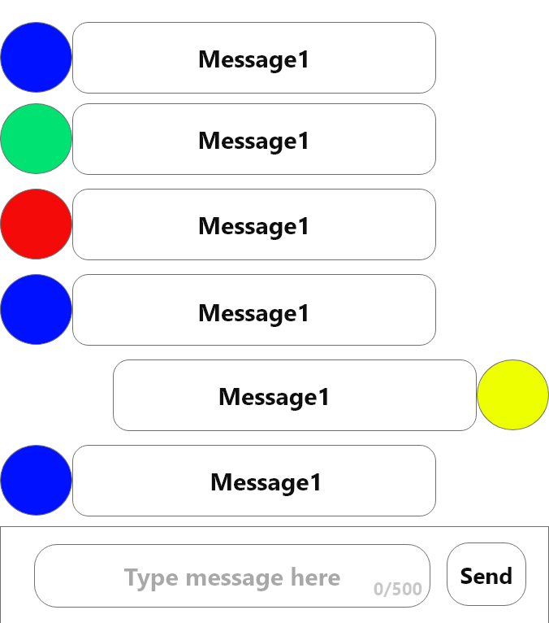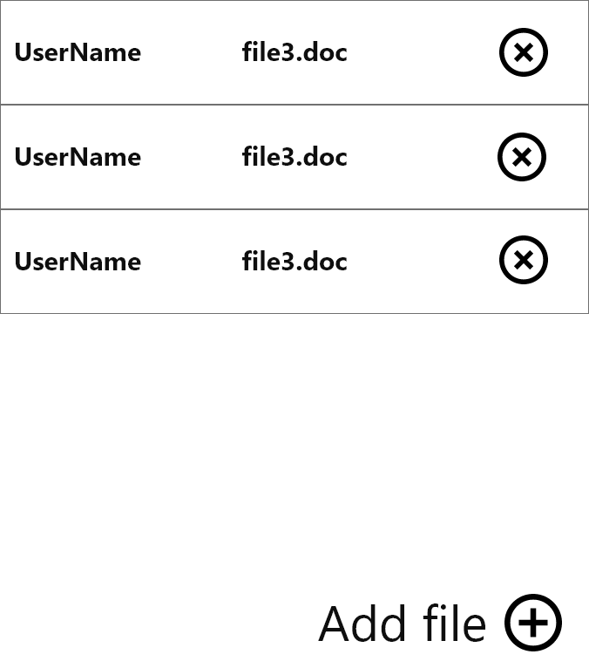

user_name
user_type
user_stars
user_email
user_password

Geo-tagging Augmented Reality GUI
Wireframe

